Implementing Test case using ATF Test Template

Step 1: Create a Test Template

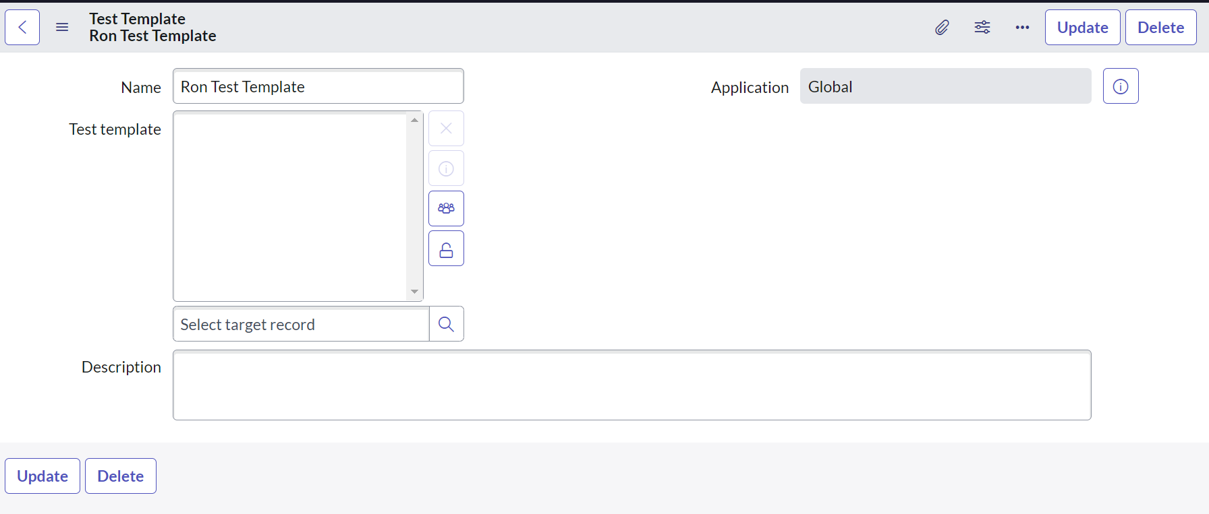

Step 2: Add preexisting Test Templates

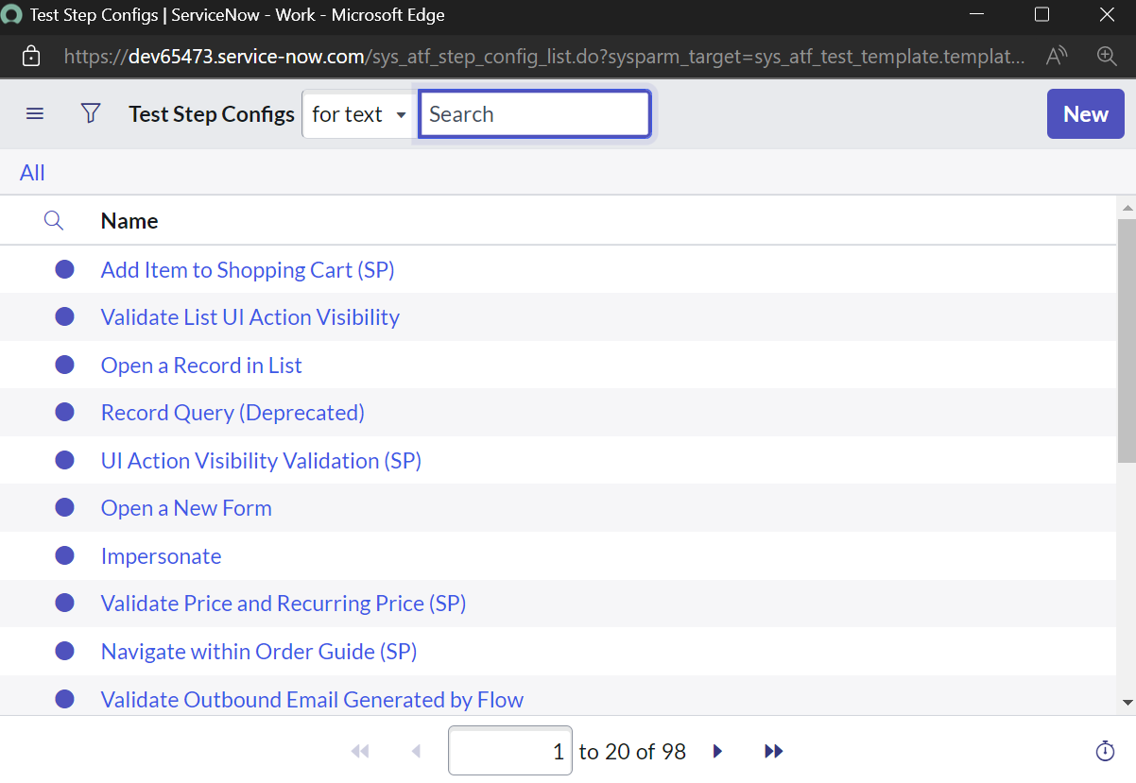

Step 3: Fill in all the Test templates

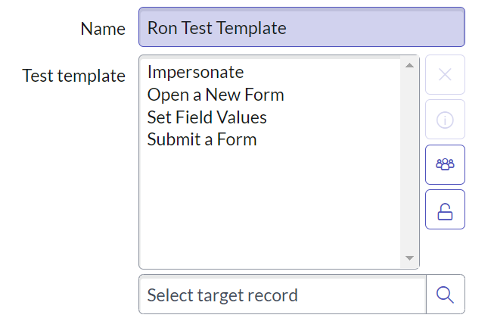

Step 4: Create an ATF Test Case

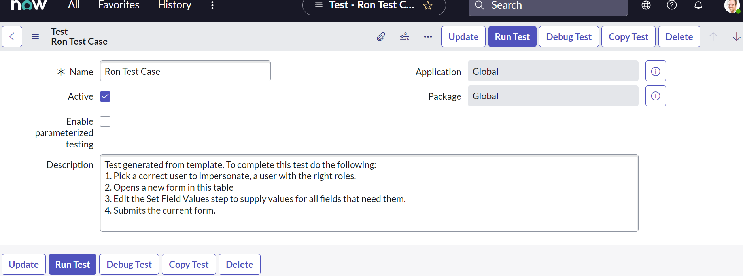

Step 5: Add the test case by importing it from the test templates

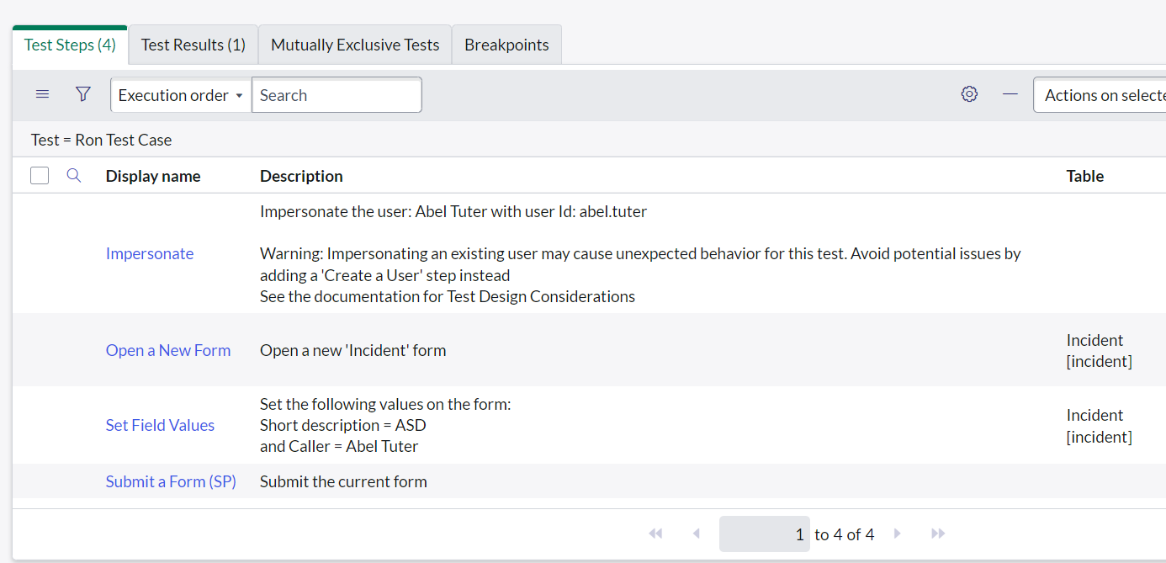

Step 6: Fill the remaining details

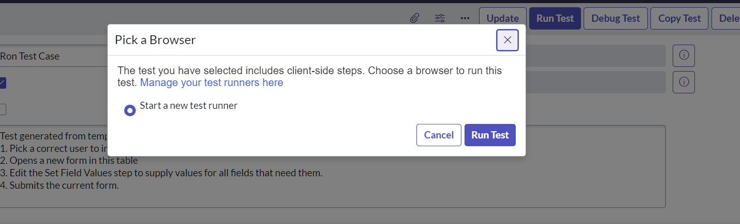

INPROGRESS:

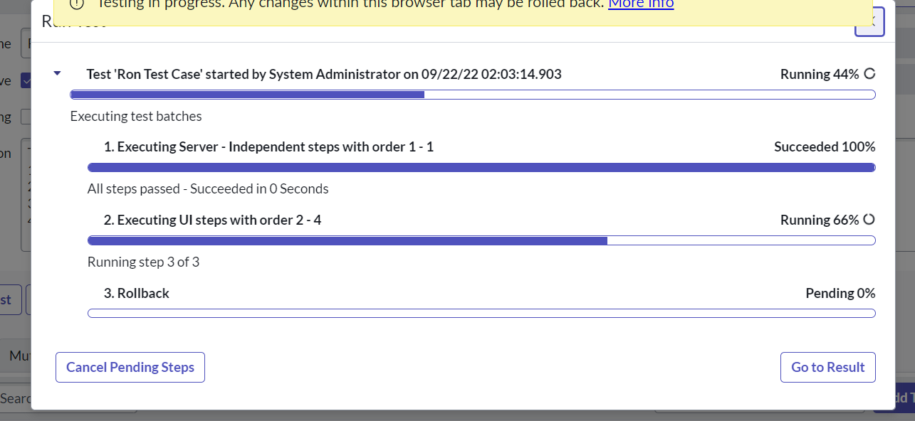

RESULTS: